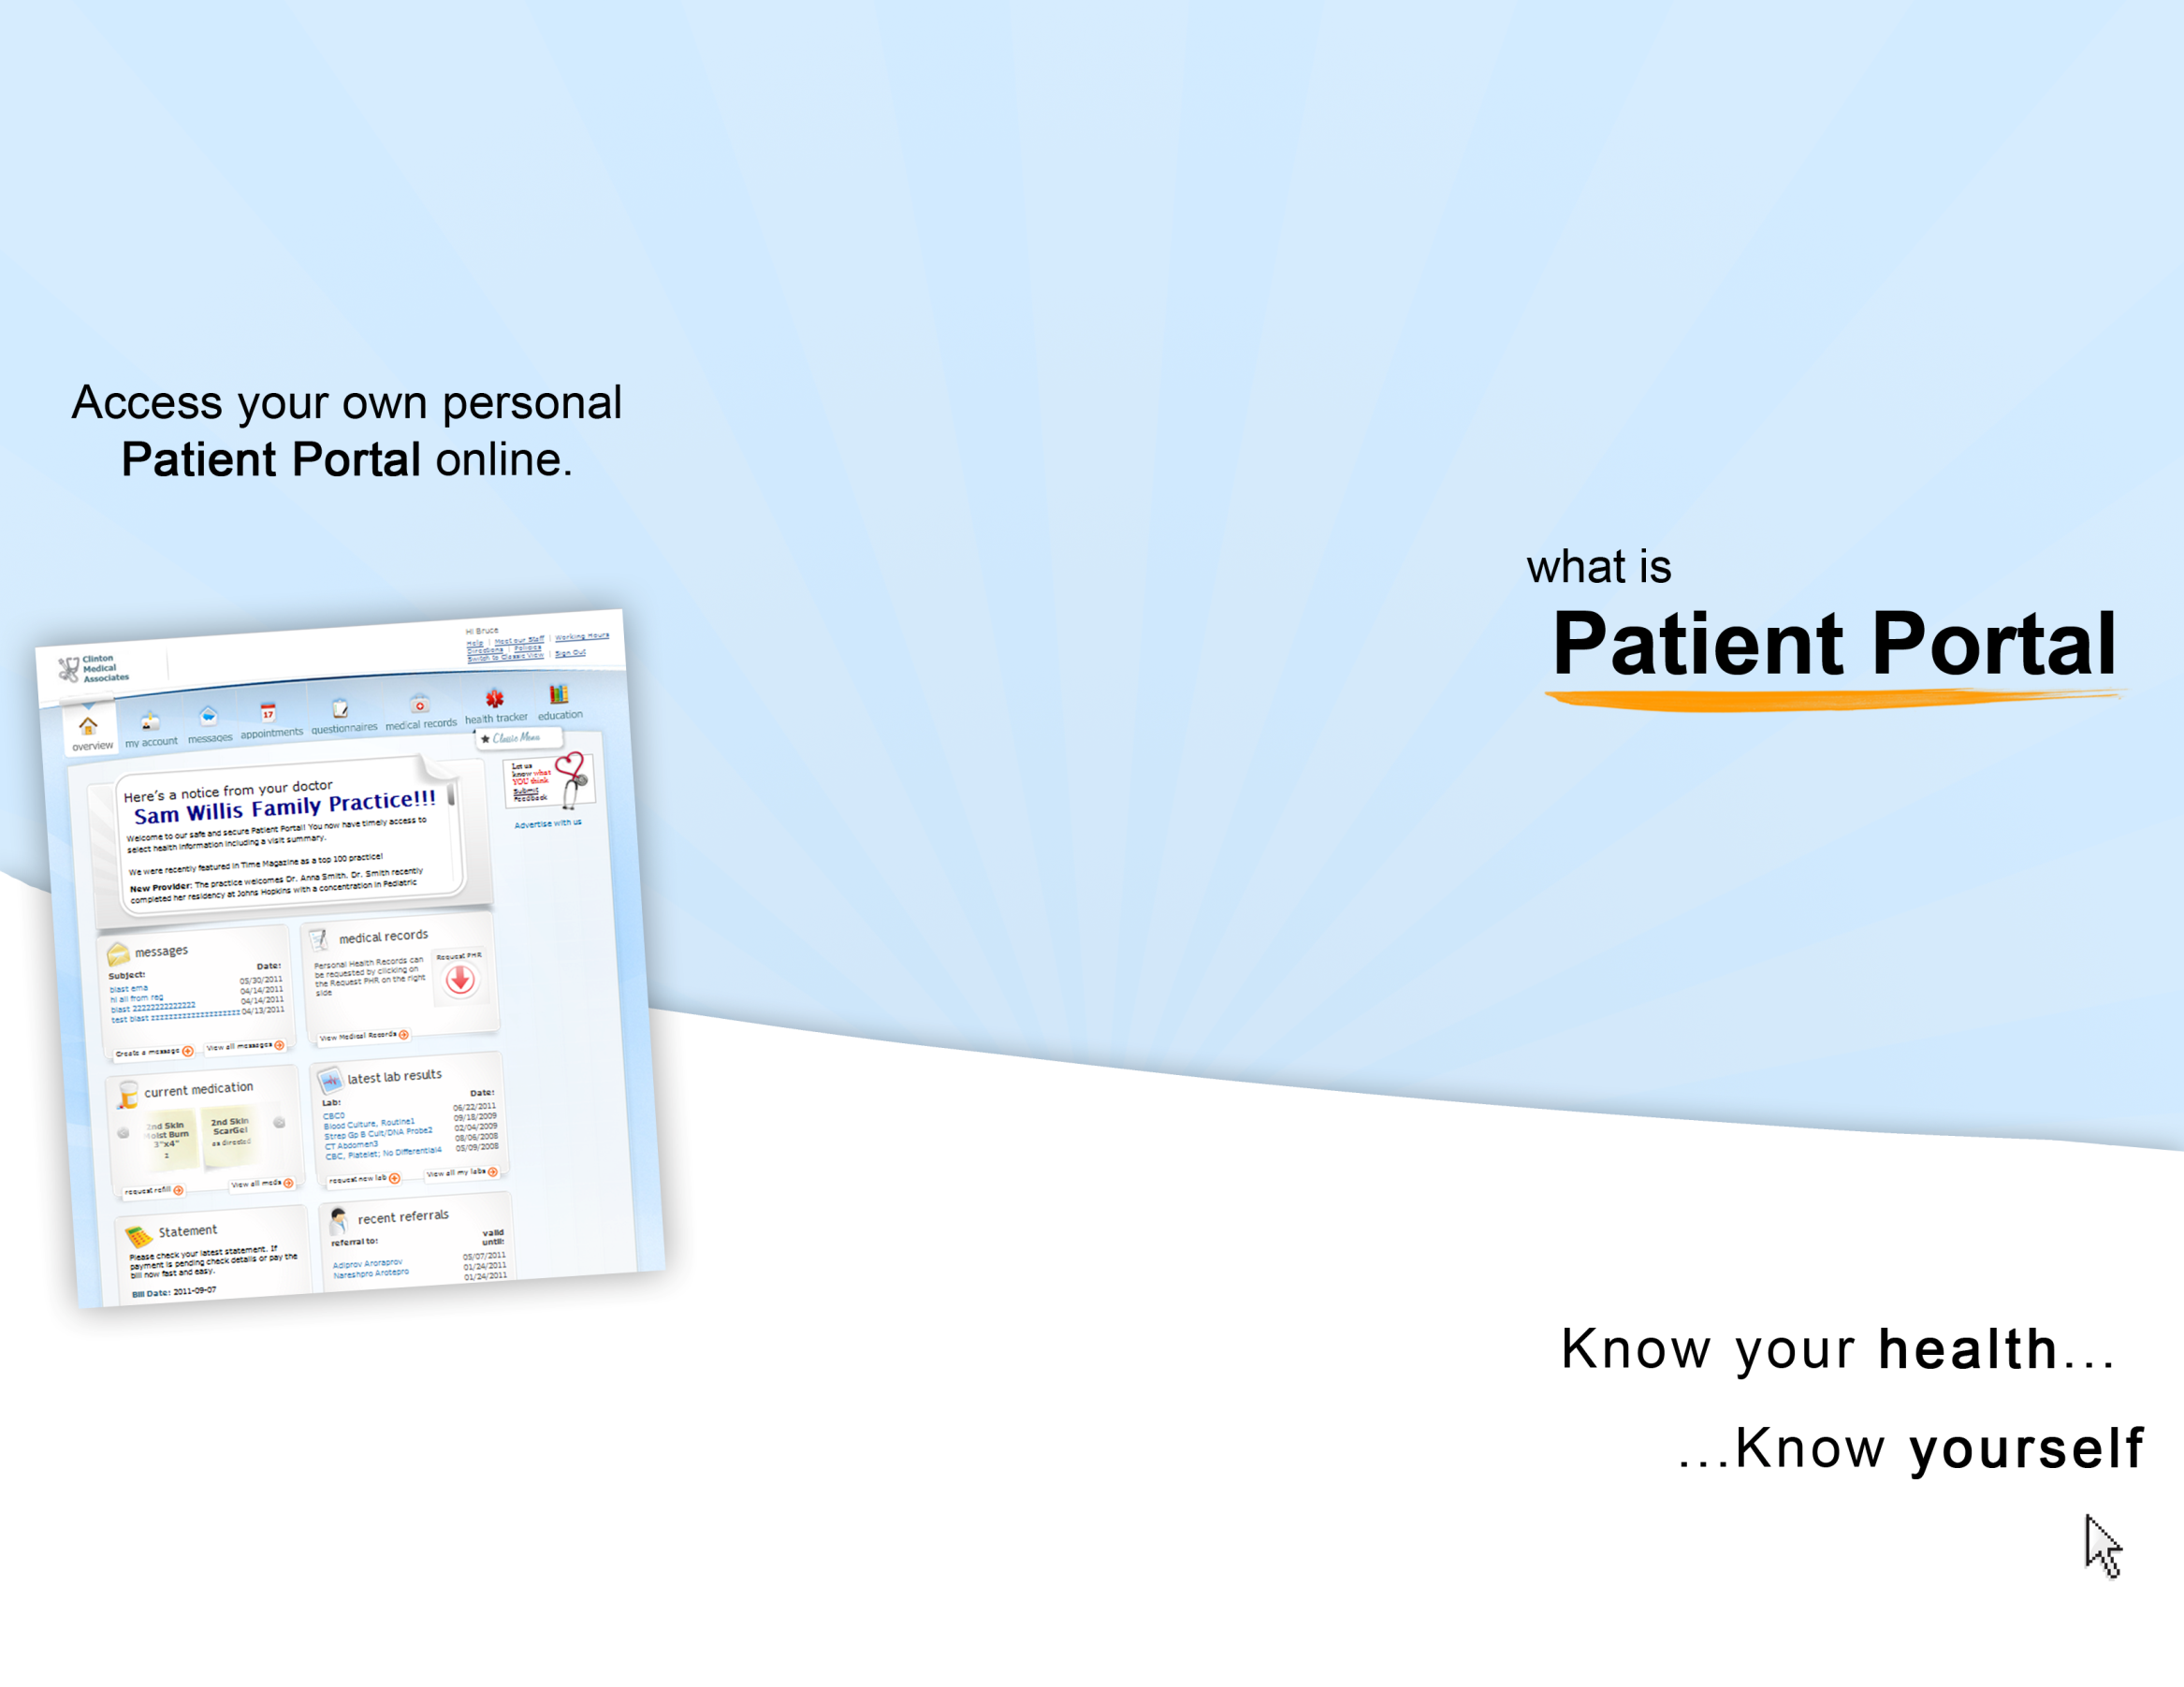
http://www.eclinicalworks.com/products-patient-portal.htm
Yolanda T. Grady, M.D., Inc.
13768 Roswell Avenue
Suite 202
Chino, CA 91710
(909) 628-4205
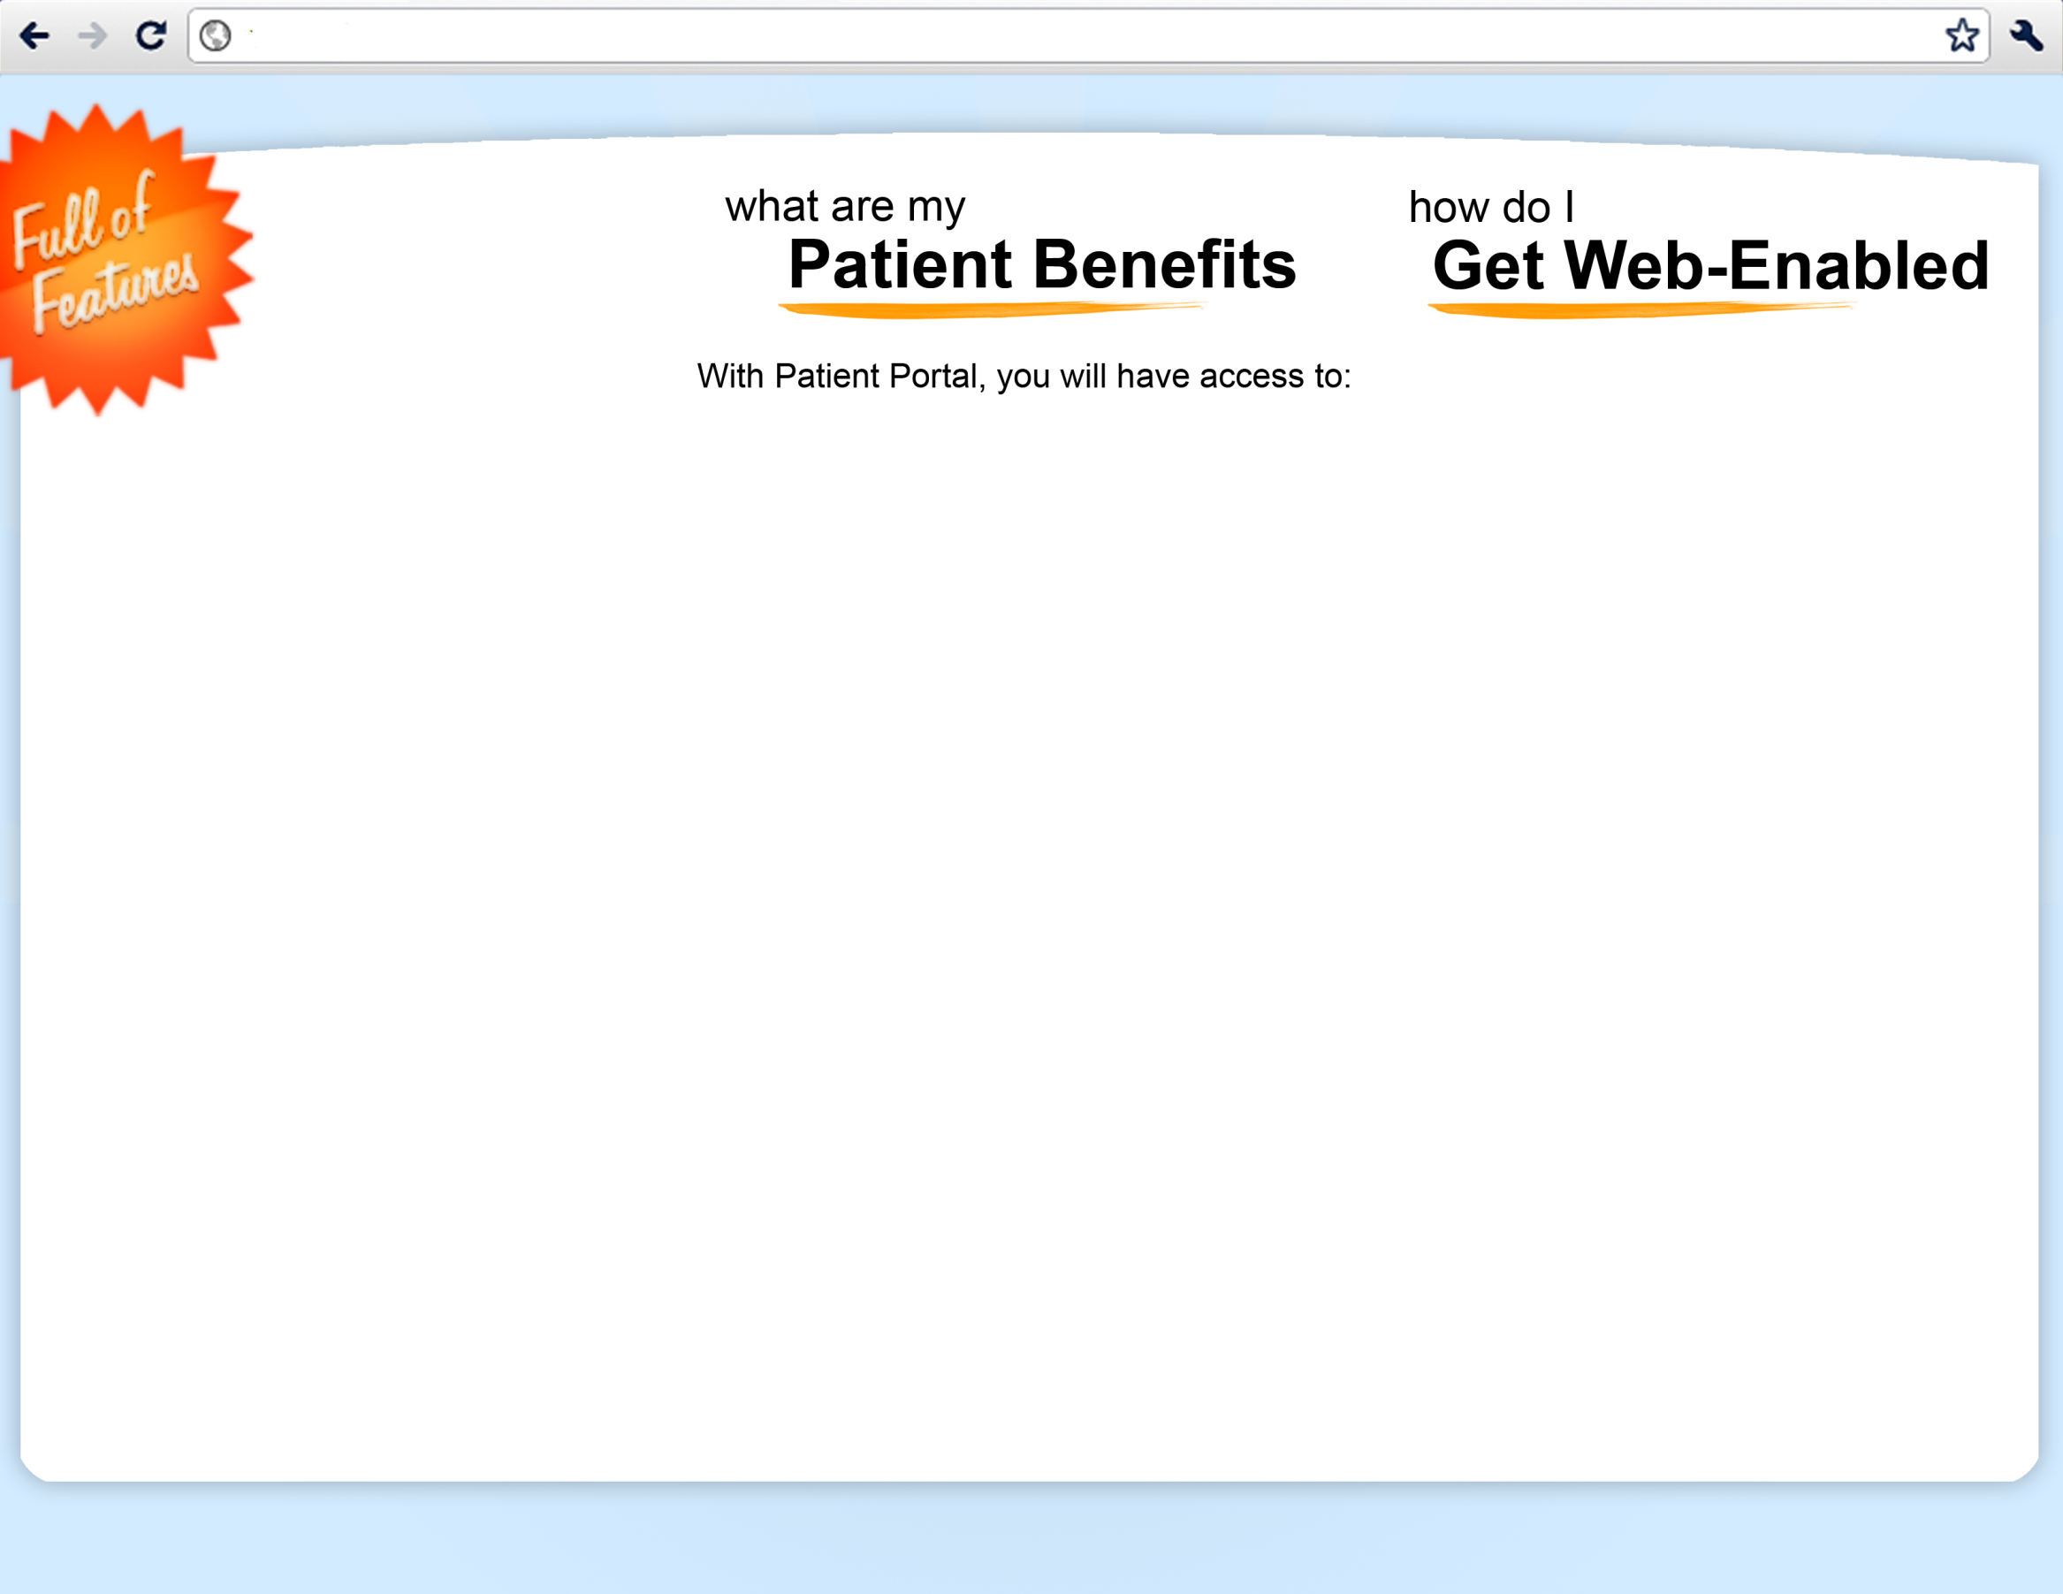
The Patient Portal is not intended for use in emergencies. If you require urgent or immediate medical care, call 911.

To gain access to our secure server on Patient Portal and become web-enabled, simply sign up by providing us with a personal (non-work) e-mail address.

You will be able to securely log in with your username and password, and gain access to your personal health record and other helpful features from any computer or smartphone with an Internet connection!
http://www.eclinicalworks.com/products-patient-portal.htm

This Practice
is now offering our patients
easy and private access to their medical information online,
so you can view your personal health record whenever and wherever you have access to the Internet!

Gain access to your private health information and receive periodic updates and reminders from your doctor on your personal e-mail address!





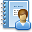












Appointments
Keep track of appointments
Lab Results
Access and view lab results
Medication
Request prescription refills
Medical Records
View your personal health record
Education
Receive educational materials
Messages
Send & receive messages from staff
Reminders
Receive health reminders
Billing
View billing statements
Demographic Information
Update demographic information
Referrals
View & request referrals

